Blackvue consulting mission

About us
We are Blackvue, well known manufacturers of Dashcams.
- Our flagship product is the Blackvue DR970X 2ch with LTE connectivity
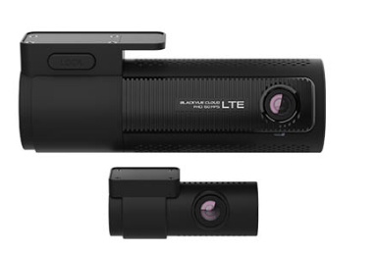
- Our entry level is the Dashcam Blackvue DR590X-1CH Plus, with Wifi support
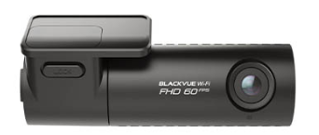

Some partnering insurances provide to our customers a 10% rebate on their subscription, as their dashcams may help identifying origin of damages and identify culprits.

Our ambition
We want to leverage the AI hype by adding AI features to our dashcams, staying ahead of competition.
We have a long track of collaboration with insurance companies, so it’s not time to get revenue from them by offering additional services.
Insurance and license plate fraud exploded in past years, following the fast increase in automated speed and parking control systems, and we see an opportunity to include fraud reduction in our main company values.

Context
Our innovation team conceptualized a proof of concept embedding an AI in our flagship product, to detect and recognize car license plates in real time. The lead architect followed a youtube video using a pretrained model for car plate recognition easily found on internet and confirmed we may deploy it in 1 or 2 months.
Our business team is now aiming at several services based on the assumption license plates and GPS coordinates will be pushed in a central database by all our products:
- Provide access to users to check their past locations, be notified if they meet a friend car on the road
- [Provide access to Insurance to define and check geofencing for specific insurance contracts (less than 50km from home)]
- Provide access to Insurance to detect stolen vehicules location
- Provide access to DMV (Department of Motor Vehicles) to identify fraudulently duplicated license plates
- [Provide access to police forces to detect vehicle presence in real time e.g. for abducted kids]
- Allow police forces to track 10 most wanted license plates
Of course we need to display “Military grade security” on our boxes, but our budget is limited and we do not want to increase the cost of our products.

Your mission
We need you to perform
- a functional PoC using a RPI, capturing license plate, uploading plate number and location, search of a license plate coordinates in the central system by insurance, searching of duplicates by DMV, with basic security measures.
- Perform a ‘light’ risk/legal assessment
- Propose a security architecture for an MVP, considering production constraints
- Propose security improvements highlighting main mitigated attack scenarios for final product

Duration
The exercise is timeboxed to 1.5mm, or 5 full days for a group of 5 people

Expectations
We expect the study to be finalized and a professional presentation on April 4th
  - 20’ presentation (English slides) on architecture and security
  - 5’ demo
  - 10’ Q&A
Audience : CEO, Lead architect, Directeur marketing.

Misc
For any question please contact gerald.maunier@free.fr

HINTS
-User may register license plate of banalized cops’ cars entering in an area
-User may track someone he has pbs with
=> tracked license plate must be authorized by its owner
-Our employee may steal DB
=> DB must be encrypted, each record with different key
-DMV employee may search any car
=> put ratio and audit log
-One cam may report false data (user displaying fake plates)
=> monitor ratio, and cipher origin
So
-each data must be encrypted with camera symmetric key derived from serial number
-data must be associated to an origin dashcam in case of abuse detection
-mqtt is maybe not the best protocol, REST on our server may do the job

